**Smart Bike Anti-Theft Packet**

**Features**

*Background:* There are three things included in this packet: a Bluetooth beacon transmitter, a mobile application and Bluetooth beacon receivers. A Bluetooth beacon transmitter is embedded in the water bottle holder, each transmitter has an unique code. The battery compartment is easy to find and open, located at the bottom of the holder, it uses one standard AA battery and each battery can support approximately one year of operation. The mobile application can be searched and downloaded from the application store and internet. The Bluetooth beacon receivers are placed strategically in many cities and shore towns.

***Additional Features***

*Led Indicator:* A Led indicator is embedded at the top of the water bottle holder. It can receive the command transmission from the Bluetooth beacon receiver. There are two modes: lock mode and unlock mode. The Led indicator becomes red in lock mode. The Led indicator becomes green in unlock mode.

*Buzzer:* A buzzer is embedded in the water bottle holder. It can receive the command transmission from the Bluetooth beacon receiver. There are two modes: alarm mode and hint mode. The buzzer makes 80db noise for 5 minutes in alarm mode. The buzzer makes 40db noise for 10 seconds in hint mode.

***Feature 1:*** Once finished installation and registration, the user can find the location of the bike on the map in the mobile application.

***Feature 2:*** The user can mark their bike as “missing” or “stolen” status in the mobile application. Once a bike is marked, the user will receive a notification containing location information immediately if the bike is detected by a Bluetooth beacon receiver, the police will also be notified.

***Feature 3:*** The user can switch their bike to “lock” or “unlock” mode in the mobile application. If the bike is in “lock” mode, the Led indicator becomes red so the user can visually see the status. Under this mode, if the bike moves out of the current Bluetooth beacon receiver’s detection range, the bike will be marked as “missing” or “stolen” status. The user will receive a notification containing location information immediately and the police will be notified. The buzzer will be triggered into alarm mode and make 80db noise for 5 minutes. If the bike is in “unlock” mode, the Led indicator becomes green so the user can visually see the status. Under this mode, the user can use the bike freely without triggering any anti-theft mechanisms.

***Feature 4:*** The user can trigger their bike’s buzzer “hint” mode in the mobile application. Once triggered, the buzzer will make 40db noise for 10 seconds to guide the user to the bike's location.

***Feature 5:*** The user can use the mobile application as a Bluetooth beacon receiver, once a stolen bike is detected, the user can report the location and notify the owner with the location information and the police.

**Architectural description**

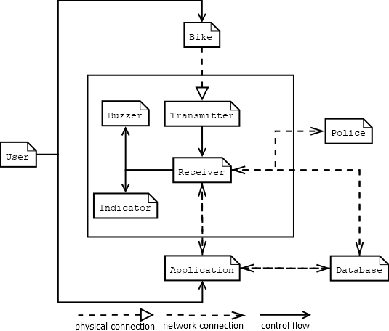

Figure 1

*User:* The component *User* is the user of this IoT device. The user owns Bike and use Mobile application to control the system.

*Bike:* The component *Bike* represents any Bike, which is the service target of this IoT device. It has a physical connection with component *Transmitter*, the component *Transmitter* must be attached to the Bike in order to construct the service environment.

*Transmitter:* The component *Transmitter* is the Bluetooth beacon transmitter in this solution system. The Bluetooth beacon transmitter is embedded in the Bike and keeps emitting signal.

*Buzzer:* The component *Buzzer* is the Buzzer embedded in this IoT device. It receives the command transmission from the component *receiver* and output audio noises based on the command received.

*Indicator:* The component *Indicator* is the Lab Indicator embedded in this IoT device. It receives the command transmission from the component *receiver* and changes colors based on the command received.

*Receiver:* The component *Receiver* is the Bluetooth beacon receiver. It receives the signal transmitted by the component *Transmitter*, and sends the data to the component *Database.* It also receives commands and data from both components *Receiver* and *Database*. Based on the data and commands received, the component *Receiver* controls the component *Indicator* and component *Buzzer*: switch component *Indicator* to a specific mode and trigger a specific mode of component *Buzzer*.

*Application:* The component *Application* is the mobile application. It is controlled by the user directly. It sends and receives data between the component *Receiver* and component *Database* simultaneously.

*Police:* The component *Police* is the law enforcement in the cities and shore towns. When a missing or stolen Bike is detected by a Bluetooth beacon receiver,the Police receive a report.

*Database:* The component *Database* is the centralized database exchange and store data between component *Application* and component *Receiver*.